KNN Model

The k-nearest neighbors (KNN) algorithm is a simple, supervised machine learning algorithm that can be used to solve both classification and regression problems. It’s easy to implement and understand, but has a major drawback of becoming significantly slows as the size of that data in use grows.

KNN works by finding the distances between a query and all the examples in the data, selecting the specified number examples (K) closest to the query, then votes for the most frequent label (in the case of classification) or averages the labels (in the case of regression).

In the case of classification and regression, we saw that choosing the right K for our data is done by trying several Ks and picking the one that works best.

Finally, we looked at an example of how the KNN algorithm could be used in recommender systems, an application of KNN-search.

K-nearest neighbors (KNN) algorithm uses ‘feature similarity’ to predict the values of new data points which further means that the new data point will be assigned a value based on how closely it matches the points in the training set. We can understand its working with the help of following steps −

**Step 1** − For implementing any algorithm, we need dataset. So during the first step of KNN, we must load the training as well as test data.

**Step 2** − Next, we need to choose the value of K i.e. the nearest data points. K can be any integer.

**Step 3** − For each point in the test data do the following −

* **3.1** − Calculate the distance between test data and each row of training data with the help of any of the method namely: Euclidean, Manhattan or Hamming distance. The most commonly used method to calculate distance is Euclidean.
* **3.2** − Now, based on the distance value, sort them in ascending order.
* **3.3** − Next, it will choose the top K rows from the sorted array.
* **3.4** − Now, it will assign a class to the test point based on most frequent class of these rows.

**Step 4** − End

Example

The following is an example to understand the concept of K and working of KNN algorithm −

Suppose we have a dataset which can be plotted as follows −

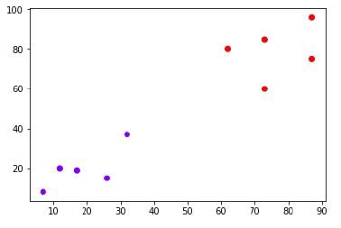

Now, we need to classify new data point with black dot (at point 60,60) into blue or red class. We are assuming K = 3 i.e. it would find three nearest data points. It is shown in the next diagram −

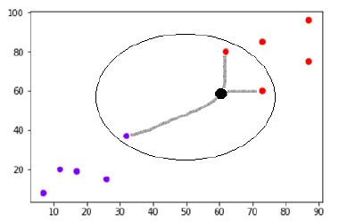

We can see in the above diagram the three nearest neighbors of the data point with black dot. Among those three, two of them lies in Red class hence the black dot will also be assigned in red class.

Implementation in Python

As we know K-nearest neighbors (KNN) algorithm can be used for both classification as well as regression. The following are the recipes in Python to use KNN as classifier as well as regressor